Handout 5.1

East African News
More deaths in Kitanga District
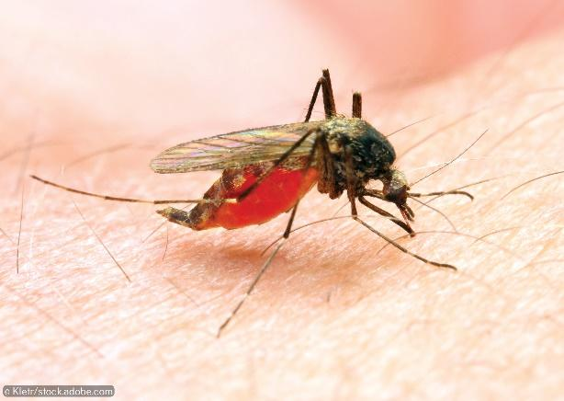
Over 1000 people live in the four villages in Kitanga District in East Africa and recent deaths from malaria are causing concern.
The Anopheles mosquito spreads malaria by biting people

Village A, the largest village with a population of 400, has already lost six people. Villages B and C have populations of 200 and 340 respectively. So far only one person has died in Village B but three people have died in Village C in the last week. Village D has a smaller population of just 100 and has not yet suffered any deaths.
Prompted by the deaths, a Government Health Minister recently visited Kitanga District and called for the immediate spraying of all the possible mosquito breeding grounds with insecticide.

However, an association of village elders does not think mass spraying is the answer. ‘Who will pay for the expensive chemicals?’ they ask. They have also expressed concern about pollution. ‘These are powerful chemicals. What effect will they have on the delicate ecosystem of the swamps which are an important source of fish as well as drinking water for our cattle? If spraying is used it will be vital to identify which swamp the mosquitos are using as their breeding ground.’
Use of mosquito nets, which prevent people from being bitten in the first place, is currently patchy. A survey has shown that 26 people in Village A use nets, 10 in village B and 15 in Village C. Village D has only three net users. The local Kitanga clinics have just published the infection rates for the four villages in the District. These are shown in the table below.

Village | Number of people infected | Number of clinics
A | 20 | 2
B | 139 | 1
C | 35 | 1
D | 88 | 0

Here is a scale map of Kitanga District.

